[Author name]
[Company name] | [Company address]
Third Party Risk Assessment Report
Vendor: Insert Vendor Name.

Moderate
High
Critical
Low
Overall Risk Rating →

Table of Contents

Executive Summary 2
Vendor Profile 4
Vendor Product & Service Information 4
Purpose 4
Vendor Assessment Scope of Work 5
Risk Assessment Approach 6
Risk Assessment Findings 8
Documentation Review 9
Identified Risks 10
Exceptions Noted 11
Recommendation 12
Conclusion 13

Executive Summary
A comprehensive risk assessment of Vendor name was completed on Date. The vendor is aligned with the specific business requirements and security standards of the client. It is recommended that CompanyX approve Vendor name. However, the identified risks must be effectively managed through strategic mitigation measures.

Key Findings:
- The assessed controls aligned with CompanyX’s security standards. The overall vendor risk for Vendor name has been evaluated and classified as Low.
- However, we identified 2 specific gaps:
  - Both the sub-controls were categorized as Moderate risk.

# | Risk Description | Risk Rating
1. | The vendor does not include credit history checks in their screening process. | Moderate (9)
2. | The vendor does not participate in globally recognized privacy programs. | Moderate (9)

Essential documentation has been tabulated below:
Description | Status | Provided by Vendor (Yes/No/N/A)
ISO 27001 Certification | Certified/Not Certified | Yes
SOC 2 Type 2 Attestation | Attested/Not attested | No

Additional Findings
- The vendor has mentioned that the parent company is SOC 2 Type 2 compliant. However, they have not provided the SOC report.
- It is mentioned that the data will not be destroyed on demand by the client but will be destroyed as per what is agreed in the client contract.
- The vendor does not participate in any privacy program or certification. However, the 27701 standard in ISO 27001 certification is on the roadmap during the next certification audit, starting in April 2025.
- Additionally, the vendor does not specifically mention public guidelines for law enforcement seeking access to customer data. It outlines the conditions under which personal information may be disclosed, including compliance with legal obligations such as court orders and government requests. However, it does not provide detailed public guidelines for law enforcement access.

The evaluation was conducted in alignment with CompanyX’s Risk Management Policy and Procedures. The assessment findings and recommendations serve as a guide for CompanyX in enhancing its vendor risk management practices. By implementing the recommended risk mitigation measures, CompanyX can improve the security posture of its vendor relationships, mitigate potential vulnerabilities, and safeguard sensitive data. CompanyX should refer to the detailed assessment report for a comprehensive analysis, specific recommendations tailored to each vendor, and additional requirements that may be relevant based on the nature of the services provided.

Vendor Profile

Vendor Product & Service Information
Name of Vendor: | Vendor name
Functionality: Briefly describe the functionality of the products or services provided

Purpose
This report assesses the effectiveness of the management, operational, and technical security controls implemented for CompanyX. It identifies relevant threats and vulnerabilities, evaluates the likelihood of exploitation, assesses the associated impact, and determines the overall risk level. The report documents the risk assessment activities conducted by SecurityPal on Date. It provides a comprehensive understanding of the potential risks to CompanyX in engaging with Vendor name as a third-party product and service provider.

Vendor Assessment Scope of Work

SecurityPal conducted a security review for Vendor name, primarily focusing on assessing their performance Based on CompanyX’s Third Party Security Standards within the Third-Party Management Policy“ Assessment of third-parties which receive, process, or store Confidential data were assessed based on the following controls as applicable based on the service provided and the sensitivity of data stored, processed or exchanged:

- Information Security Policy
Review of Third-parties information security policies supported by their executive management, and review cycles.
- Risk Assessment and Treatment
Review of Third-party programs that assess, evaluate, and manage information and technology risks.
- Operations Security
Review of third parties’s commercially reasonable practices and procedures designed to maintain operations security of
- Technical testing
- Protection against malicious software
- Network protection and management
- Technical vulnerability management
- Logging and monitoring
- Incident response
- Business continuity planning
- Access Control
Review of Third-party’s technical access control program.
- Secure System Development
Review of Third-party’s secure development program consistent with industry software and systems development best practices, including risk assessment, formal change management, code standards, code review, and testing.
- Physical and environmental Security
Review of Third-party physical and environmental security controls per the CompanyX Physical Security Policy requirements.
- Human Resources
Review of Third-party’s human resource policies and processes, which include criminal background checks where permitted by applicable law for any employees or contractors who access CompanyX Customer Data information.
- Compliance and Legal
Review of all applicable regulations and laws relevant to the supplier or third parties who will access, store, process, or transmit CompanyX Confidential data. The following criteria were assessed as applicable:

- Protection of customer data, organizational records, and records retention and disposition
- Privacy of Personally Identifiable Information (PII)
- Compliance with data deletion and retention requirements.

Risk Assessment Approach
This risk assessment is conducted as per CompanyX’s Risk management policies and procedures and following NIST SP 800-30, Guide for Conducting Risk Assessments. Risks were evaluated by considering threat events, their likelihood of occurrence, system vulnerabilities, mitigating factors, and the potential consequences/impact on the mission.

SecurityPal utilized a security questionnaire template to gather pertinent information for conducting a vendor security assessment. This questionnaire covers areas mentioned in Section “Vendor Assessment Scope of Work” of this report. Additionally, the following documents provided by the vendors were reviewed as a part of the assessment:
- Vendor DDQ Survey
- ISO 27001
- MSA

SecurityPal also collected the necessary information by reviewing vendor websites, and security documentation and contacting the vendor's InfoSec & GRC teams for support as needed.

The following tables derived from CompanyX’s Risk Management Policy were used to assign values to likelihood, impact, and risk:
Impact Levels and Description
Impact | Impact Description
Negligible(1) | A threat event could be expected to have no or negligible adverse effect.
Minor(2) | A threat event could be expected to have limited adverse effect, meaning: degradation of mission capability yet primary functions can still be performed; minor damage; minor financial loss; or range of effects is limited to some cyber resources but no critical resources.
Major(3) | A threat event could be expected to have an adverse effect, meaning: significant degradation of mission capability yet primary functions can still be performed at a reduced capacity; damage; financial loss; or range of effects is significant to some cyber resources and some critical resources.
Severe(4) | A threat event could be expected to have a significant adverse effect, meaning: severe degradation or loss of mission capability and one or more primary functions cannot be performed; major damage; major financial loss; loss of critical IP; or range of effects is extensive to most cyber resources and most critical resources
Catastrophic(5) | A threat event could be expected to have a catastrophic or critical adverse effect, meaning: complete degradation or loss of mission capability and several primary functions cannot be performed; critical damage; critical financial loss; or range of effects is catastrophic to most cyber resources and most critical resources. An example would include a compromise of an Azure root identity.
Likelihood Levels and Descriptions
Likelihood | Likelihood Description
Rare(1) | Adversary is highly unlikely to initiate a threat event. On a five-year event horizon, there is a less than 5% chance of this threat event transpiring.
Unlikely(2) | Adversary is unlikely to initiate a threat event. On a five-year event horizon, there is a 5-20% chance of this  threat event transpiring.
Possible(3) | Adversary is likely to initiate a threat event. On a five-year event horizon, there is a 20-80% chance of this threat event transpiring.
Probable(4) | Adversary is highly likely to initiate a threat event. On a five-year event horizon, there is a 80-95% chance of this threat event transpiring.
Certain(5) | Adversary is certain to initiate a threat event. On a five-year event horizon, there is a greater than 95% chance of this threat event transpiring.
Risk Matrix
Risk = Likelihood * Impact |  | Likelihood
 |  | Certain(5) | Probable(4) | Possible(3) | Unlikely(2) | Rare(1)
Impact | Catastrophic(5) | 25 | 20 | 15 | 10 | 5
 | Severe(4) | 20 | 16 | 12 | 8 | 4
 | Major(3) | 15 | 12 | 9 | 6 | 3
 | Minor(2) | 10 | 8 | 6 | 4 | 2
 | Negligible(1) | 5 | 4 | 3 | 2 | 1
Risk Levels and Descriptions
Risk Level | RIsk Description
Low  (1-3) | A threat event could be expected to have a limited adverse effect on organizational operations, mission capabilities, assets, individuals, customers or other organizations.
Moderate  (4-9) | A threat event could be expected to have a significant adverse effect on organizational operations, mission capabilities, assets, individuals, customers or other organizations.
High  (10-19) | A threat event could be expected to have a significant adverse effect on organizational operations, mission capabilities, assets, individuals, customers or other organizations
Critical  (20-25) | A threat event could be expected to have a critical adverse effect on organizational operations, mission capabilities, assets, individuals, customers or other organizations.

Risk Assessment Findings
SecurityPal performed the vendor risk assessment between CompanyX and Vendor name on Date. The majority of controls were found to be in alignment with CompanyX's Vendor Management Policy. However, no gaps were identified during the assessment.
Risk Level | Risk Count
Low(1-3) | 85
Moderate (4-9) | 2
High(10-19) | 0
Critical(20-25) | 0

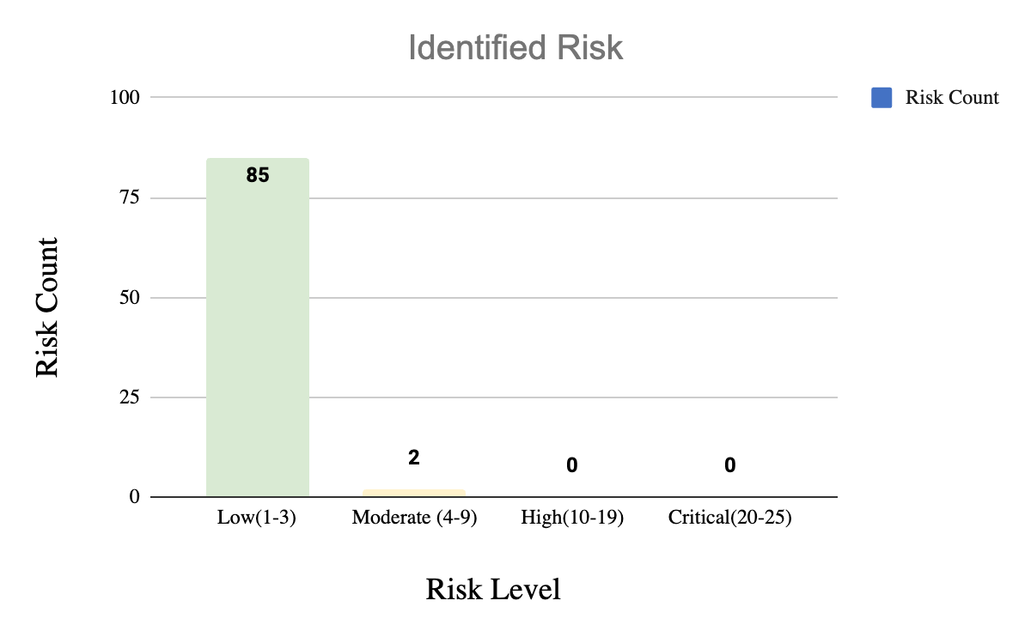

Documentation Review
Required Document | Status | Vendor Comment | Exception Noted | Remarks
Data Processing Addendum (DPA) | Not uploaded | None | No exception noted. | None
ISO 27001 | Uploaded | None | No exceptions noted. | None
MSA | Uploaded | None | Exception noted. | The MSA is yet to be signed by both parties.
SOW | Not Uploaded | None | No exceptions noted. | None
Pentest Report | Not uploaded | None | No exceptions noted. | None
SOC 2 Type 2 | Not uploaded | None | No exception noted. | None
SOC 1 Type 2 | Not uploaded | None | No exceptions noted. | None

Identified Risks
Risk | #1
Risk Description | The vendor does not include credit history checks in their screening process.
Likelihood | Possible (3)
Impact | Major (3)
Risk Level | Moderate (9)
Proposed Remediation | Implement comprehensive background checks encompassing credit assessments as part of the vendor's screening process to mitigate potential risks effectively.
Vendor’s Comment

Risk | #2
Risk Description | The vendor does not participate in globally recognized privacy programs.
Likelihood | Possible (3)
Impact | Major(3)
Risk Level | Moderate(9)
Proposed Remediation | The vendor does not participate in globally recognized privacy programs and has not obtained relevant certifications such as ISO/IEC 27701:2019 (Privacy Information Management System), GDPR (General Data Protection Regulation) Compliance, Privacy Shield, BS 10012:2017 (Personal Information Management), NIST Privacy Framework, and TrustArc (formerly TRUSTe).  Participation in these programs and adherence to their standards can demonstrate commitment to data privacy and help manage privacy risks effectively.
Vendor’s Comment | Presidio will add 27701 standard to our ISO 27001 certification during the next certification audit, starting in April 2025. Outside counsel is being consulted to review new and current documents to reflect this standard.

Exceptions Noted
- The vendor has mentioned that the parent company is SOC 2 Type 2 compliant. However, they have not provided the SOC report.
- It is mentioned that the data will not be destroyed on demand by the client but will be destroyed as per what is agreed in the client contract.
- The vendor does not participate in any privacy program or certification. However, the 27701 standard in ISO 27001 certification is on the roadmap during the next certification audit, starting in April 2025.
- Additionally, the vendor does not specifically mention public guidelines for law enforcement seeking access to customer data. It outlines the conditions under which personal information may be disclosed, including compliance with legal obligations such as court orders and government requests. However, it does not provide detailed public guidelines for law enforcement access.
- The MSA is yet to be signed by both parties.

Additionally, the vendor did not submit the following documents:
- Data Processing Addendum (DPA)
- Mutual NDA
- Order Form
- Quote
- Pentest Report
- SOC 1 Type 2
- SOC 2 Type 2
- SOW

Recommendation
After conducting a comprehensive review of Vendor name on Date, it is evident that the vendor is aligned with the specific business requirements and goals of CompanyX. The vendor has demonstrated cooperation by providing the required assessment documents and additional resources regarding its IT policies and practices.
After a thorough risk assessment, it is recommended that CompanyX approve the vendor as their offerings are aligned with CompanyX’s needs, and the identified risks can be effectively managed through strategic mitigation measures.

Conclusion
In conclusion, majority controls are aligned with CompanyX's Third Party Security Standards within the Third-Party Management Policy. As a result of the assessment, we identified two specific gaps. Both the sub-controls are classified as having a moderate risk level. We have provided appropriate recommendations to mitigate these risks effectively. The vendor risk assigned to Vendor name is classified as Low, considering the nature of the products, services, and identified risk factors. By adhering to the assessment findings and recommendations, CompanyX can strengthen its vendor risk management practices and ensure the security of its systems and data.
CompanyX is encouraged to refer to the detailed assessment report for a thorough analysis, tailored recommendations for each risk, and any additional requirements specific to the services provided.

